Sorting Algorithms
Design and Analysis of Algorithms (DAA)

Bubble Sort | Insertion Sort | Quick Sort | Merge Sort

Name: aryan maheshwari
Batch: 20
SAP ID: 590026023

UPES Dehradun

1. Introduction

Sorting is one of the most fundamental and frequently performed operations in computer science. It refers to the process of arranging elements of a list or array in a particular order — typically ascending or descending. Efficient sorting is critical because it directly affects the performance of other algorithms such as searching, merging, and data retrieval.
This document covers four classical sorting algorithms studied in Design and Analysis of Algorithms (DAA): Bubble Sort, Insertion Sort, Quick Sort, and Merge Sort — each with logic, C implementation, time complexity, and graph analysis.

2. Bubble Sort

2.1 Concept
Bubble Sort is the simplest sorting algorithm. It works by repeatedly comparing adjacent elements and swapping them if they are in the wrong order. With each full pass through the array, the largest unsorted element "bubbles up" to its correct position at the end.

2.2 Working Logic
• Compare adjacent elements: if a[j] > a[j+1], swap them.
• After each pass, the largest element settles at the end.
• Repeat for n-1 passes total.
• Optimized version: stop early if no swaps in a pass (already sorted).

2.3 C Program
#include <stdio.h>
void bubbleSort(int a[], int n) {
int i, j, temp;
for(i = 0; i < n-1; i++) {
for(j = 0; j < n-i-1; j++) {
if(a[j] > a[j+1]) {
temp = a[j];
a[j] = a[j+1];
a[j+1] = temp;
}
}
}
}
int main() {
int a[] = {5, 2, 4, 1, 3};
int n = 5, i;
bubbleSort(a, n);
for(i = 0; i < n; i++)
printf("%d ", a[i]);
return 0;
}

2.4 Time Complexity
Case | Complexity | Reason
Best Case | O(n) | Already sorted — optimized version exits early
Average Case | O(n²) | Random order — compares most pairs
Worst Case | O(n²) | Reverse sorted — max swaps needed
Space | O(1) | In-place sorting, no extra array

3. Insertion Sort

3.1 Concept
Insertion Sort works similarly to how we sort playing cards. It picks one element at a time from the unsorted portion and inserts it at the correct position in the already sorted portion. The left part of the array is always sorted and grows with each step.

3.2 Working Logic
• Start with the second element (index 1) as the key.
• Compare key with elements in the sorted portion (left side).
• Shift elements greater than key one position to the right.
• Insert key at the correct position.
• Repeat for all remaining elements.

3.3 C Program
#include <stdio.h>
void insertionSort(int a[], int n) {
int i, j, key;
for(i = 1; i < n; i++) {
key = a[i];
j = i - 1;
while(j >= 0 && a[j] > key) {
a[j+1] = a[j];
j--;
}
a[j+1] = key;
}
}
int main() {
int a[] = {5, 2, 4, 1, 3};
int n = 5, i;
insertionSort(a, n);
for(i = 0; i < n; i++)
printf("%d ", a[i]);
return 0;
}

3.4 Time Complexity
Case | Complexity | Reason
Best Case | O(n) | Already sorted — inner while loop never executes
Average Case | O(n²) | Partial shifts needed for each element
Worst Case | O(n²) | Reverse sorted — maximum shifts every step
Space | O(1) | In-place sorting, no extra array

4. Quick Sort

4.1 Concept
Quick Sort is a divide-and-conquer algorithm. It selects a pivot element, partitions the array so that all elements smaller than pivot go to its left and all larger go to the right, then recursively applies the same logic to both halves. It is one of the fastest sorting algorithms in practice.

4.2 Working Logic
• Choose a pivot (commonly the last element).
• Partition: move all elements < pivot to the left, > pivot to the right.
• Place pivot in its correct final position.
• Recursively sort the left and right sub-arrays.
• Base case: sub-array of size 0 or 1 is already sorted.

4.3 C Program
#include <stdio.h>
void quickSort(int a[], int low, int high) {
int i, j, pivot, temp;
if(low < high) {
pivot = a[high];
i = low - 1;
for(j = low; j < high; j++) {
if(a[j] < pivot) {
i++;
temp = a[i]; a[i] = a[j]; a[j] = temp;
}
}
temp = a[i+1]; a[i+1] = a[high]; a[high] = temp;
quickSort(a, low, i);
quickSort(a, i+2, high);
}
}
int main() {
int a[] = {5, 2, 4, 1, 3};
int n = 5, i;
quickSort(a, 0, n-1);
for(i = 0; i < n; i++)
printf("%d ", a[i]);
return 0;
}

4.4 Time Complexity
Case | Complexity | Reason
Best Case | O(n log n) | Pivot always splits array into equal halves
Average Case | O(n log n) | Random pivot gives balanced partitions
Worst Case | O(n²) | Pivot always smallest/largest (sorted array)
Space | O(log n) | Recursive call stack depth

5. Merge Sort

5.1 Concept
Merge Sort is a stable, divide-and-conquer algorithm. It recursively divides the array into two halves until each sub-array has one element (base case), then merges them back in sorted order. Unlike Quick Sort, Merge Sort always guarantees O(n log n) performance.

5.2 Working Logic
• Divide the array into two halves from the middle.
• Recursively sort the left half.
• Recursively sort the right half.
• Merge both sorted halves into one sorted array.
• Base case: single element is trivially sorted.

5.3 C Program
#include <stdio.h>
void merge(int a[], int l, int m, int r) {
int i = l, j = m+1, k = 0;
int temp[100];
while(i <= m && j <= r) {
if(a[i] < a[j]) temp[k++] = a[i++];
else temp[k++] = a[j++];
}
while(i <= m) temp[k++] = a[i++];
while(j <= r) temp[k++] = a[j++];
for(i = l, k = 0; i <= r; i++, k++)
a[i] = temp[k];
}
void mergeSort(int a[], int l, int r) {
if(l < r) {
int m = (l+r)/2;
mergeSort(a, l, m);
mergeSort(a, m+1, r);
merge(a, l, m, r);
}
}
int main() {
int a[] = {5, 2, 4, 1, 3};
int n = 5, i;
mergeSort(a, 0, n-1);
for(i = 0; i < n; i++)
printf("%d ", a[i]);
return 0;
}

5.4 Time Complexity
Case | Complexity | Reason
Best Case | O(n log n) | Always divides into equal halves
Average Case | O(n log n) | Consistent splitting and merging
Worst Case | O(n log n) | Same division regardless of input order
Space | O(n) | Temp array needed during merge step

6. Time Complexity Graph Analysis

The following graphs visualize the performance of all four sorting algorithms under different input sizes and cases, making it easy to compare their efficiency at a glance.

6.1 Overall Time Complexity Curves
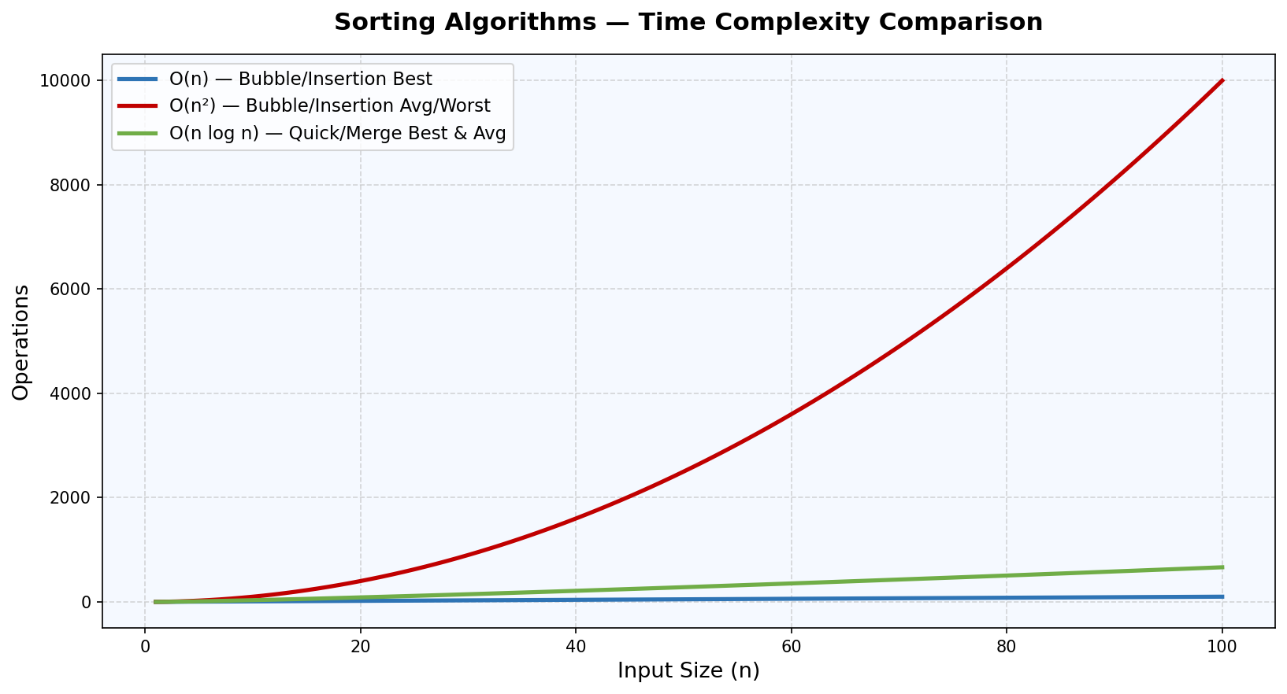
Fig 1: O(n), O(n²), and O(n log n) growth curves — shows why Merge/Quick Sort outperform Bubble/Insertion at large n

6.2 Operations at n = 100 (Worst/Average Case)
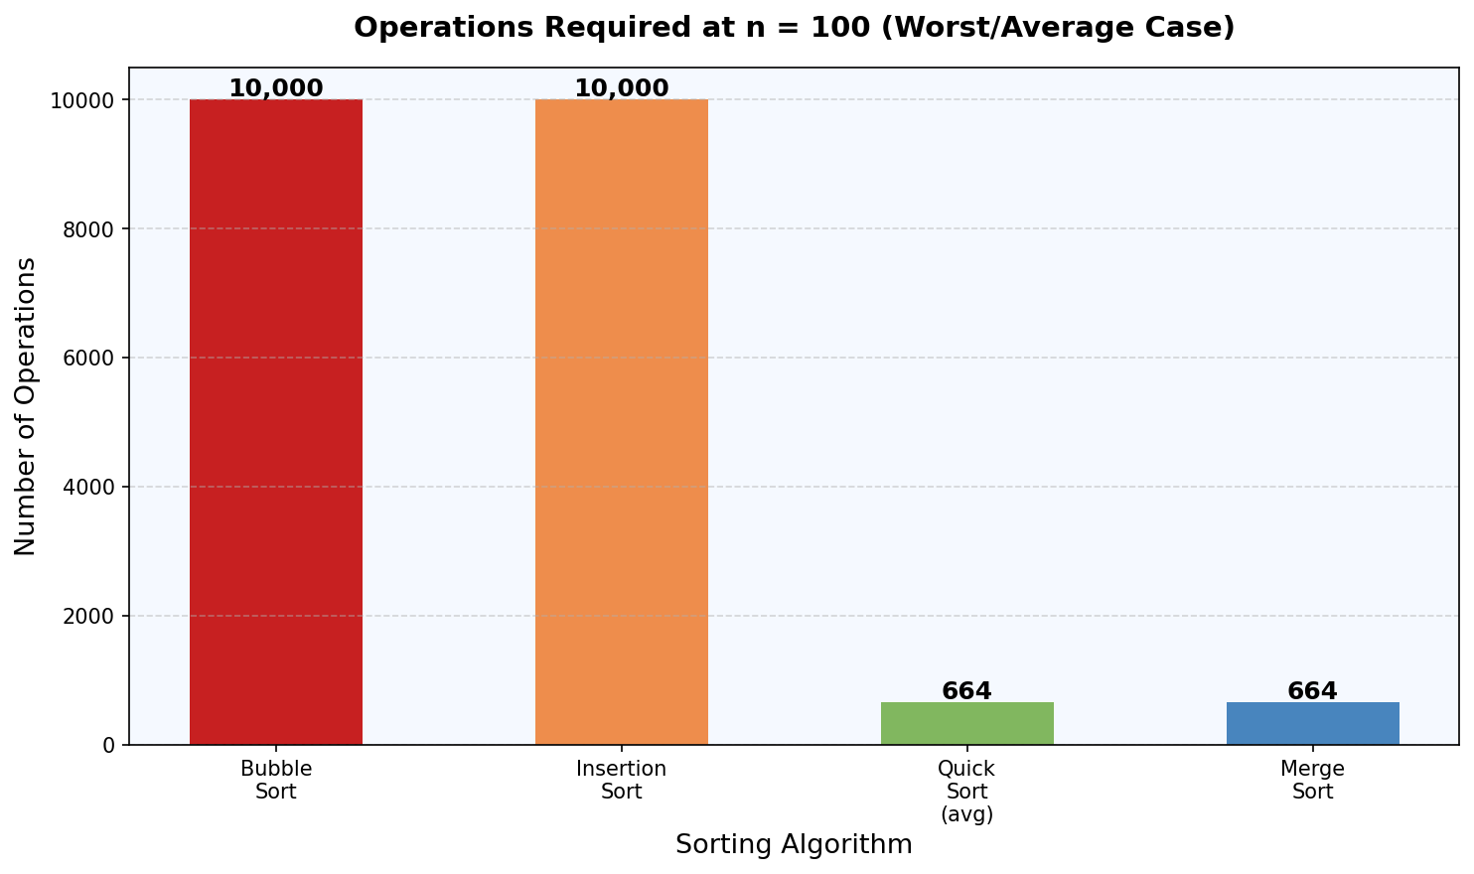
Fig 2: Bubble and Insertion need 10,000 operations vs just 665 for Quick/Merge Sort at n=100

6.3 Quick Sort vs Merge Sort — All Cases
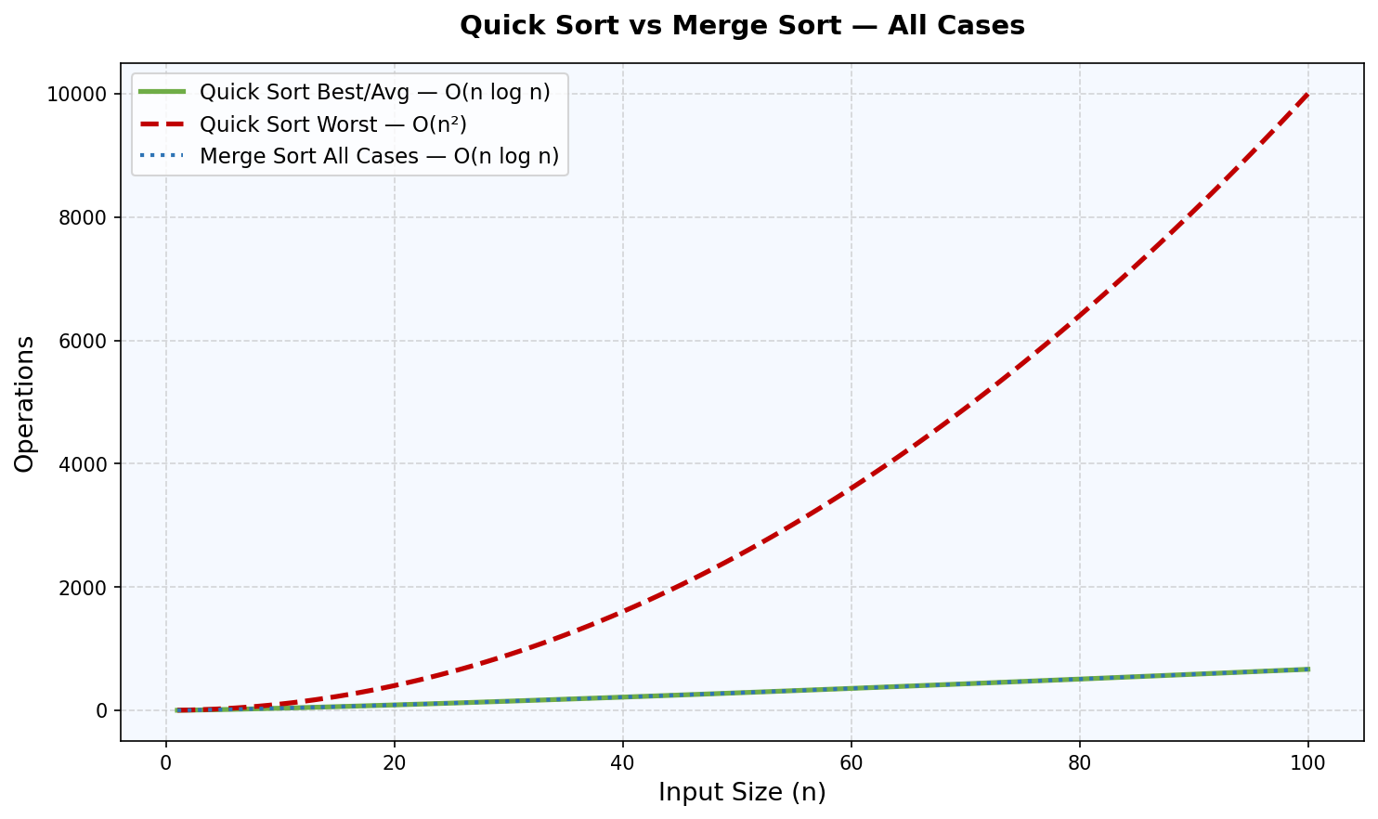
Fig 3: Quick Sort worst case degrades to O(n²) on sorted input; Merge Sort stays O(n log n) always

6.4 Best / Average / Worst Case — All 4 Algorithms (n = 50)
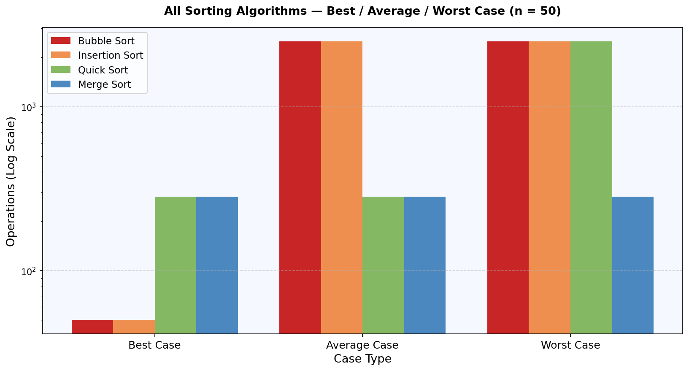
Fig 4: Grouped comparison — Merge Sort is the only algorithm with consistent O(n log n) across all cases

7. Quick Revision Table

Algorithm | Best Case | Average Case | Worst Case | Space
Bubble Sort | O(n) | O(n²) | O(n²) | O(1)
Insertion Sort | O(n) | O(n²) | O(n²) | O(1)
Quick Sort | O(n log n) | O(n log n) | O(n²) | O(log n)
Merge Sort | O(n log n) | O(n log n) | O(n log n) | O(n)

8. Key Differences & Memory Tips

8.1 Easy Way to Remember
Bubble Sort: Compare and swap neighbors — simplest, slowest
Insertion Sort: Pick and insert into correct position — good for nearly sorted data
Quick Sort: Choose pivot, partition left/right — fastest in practice but unstable worst case
Merge Sort: Divide into halves, sort, merge back — guaranteed O(n log n), needs extra space

8.2 When to Use Which?
Algorithm | Best Used When
Bubble Sort | Educational purpose / very small datasets
Insertion Sort | Data is nearly sorted or arrives in real-time (online sorting)
Quick Sort | Large general-purpose datasets; average performance matters most
Merge Sort | Stability required; linked lists; guaranteed performance needed

9. Conclusion

Sorting algorithms are a cornerstone of algorithm design and analysis. Each of the four algorithms covered here offers a different trade-off between simplicity, performance, and memory usage.

Bubble Sort and Insertion Sort are intuitive and simple, but their O(n²) average and worst-case complexities make them unsuitable for large datasets. Quick Sort offers excellent average-case performance of O(n log n) and is widely used in practice, but its worst-case O(n²) is a concern for sorted inputs unless randomized pivot selection is used. Merge Sort provides the most predictable performance with O(n log n) in all cases, at the cost of O(n) extra space.

For exams: Always write Best, Average, Worst Case, and Space Complexity for each algorithm. Understanding the reasoning behind each complexity is more important than memorizing the values.

— End of Document —

